DATABASE SYSTEMS ENGINEERING AND DISTRIBUTED BACKEND DEVELOPMENT

WEEK – 2

2520030371 – P. HAVISHAA REDDY

Step 1 — Create Database:

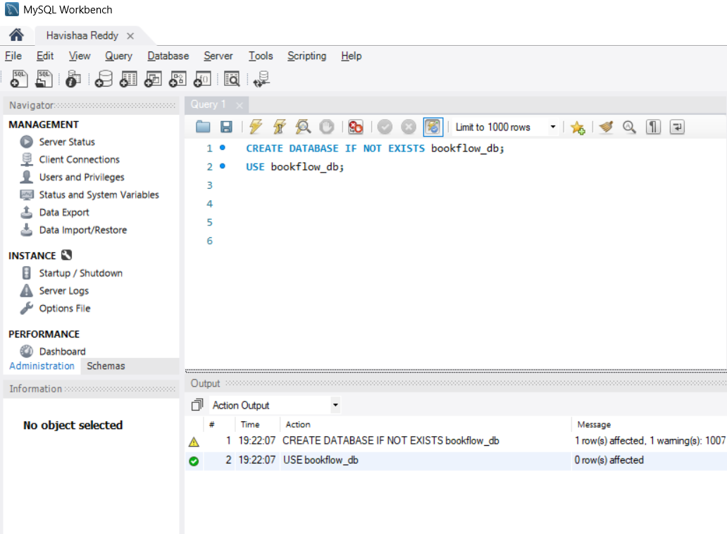

Step 2 — Create Books Table (DDL + Constraints)
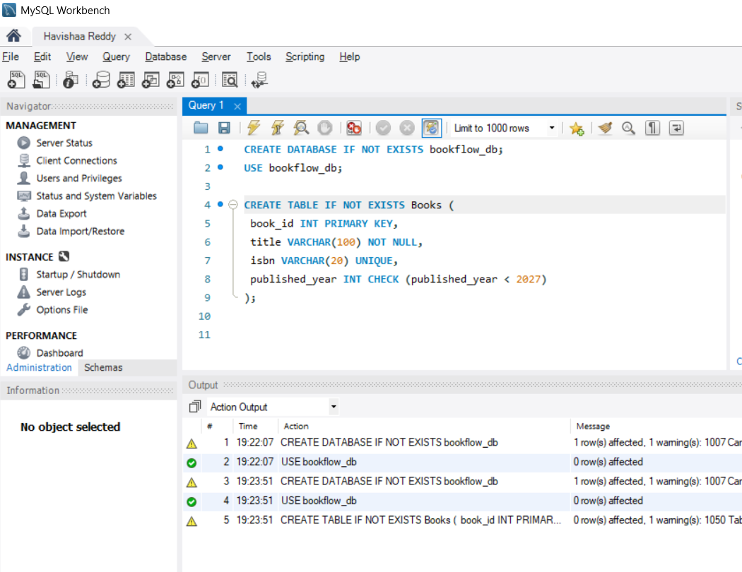

Step 3 & 4 — Insert Books and Display:
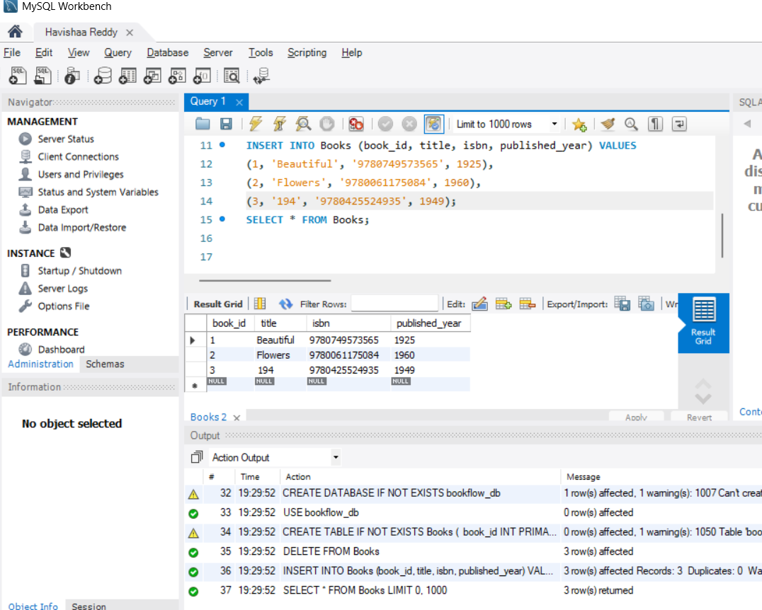

Step 5, 6 & 7 — Members Table: Create, Insert, Display:
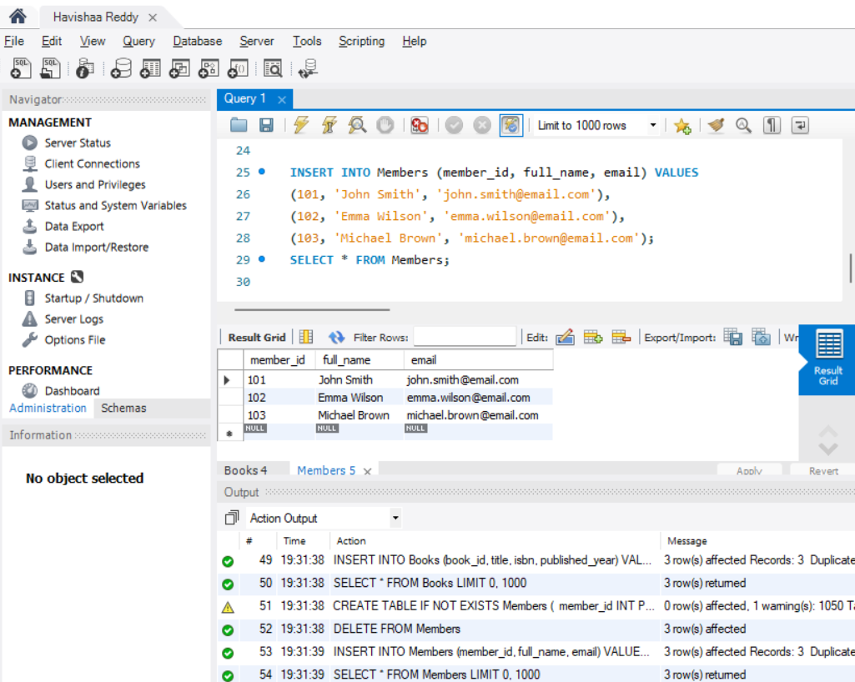

Step 8 — Create Loans Table (FOREIGN KEYS):
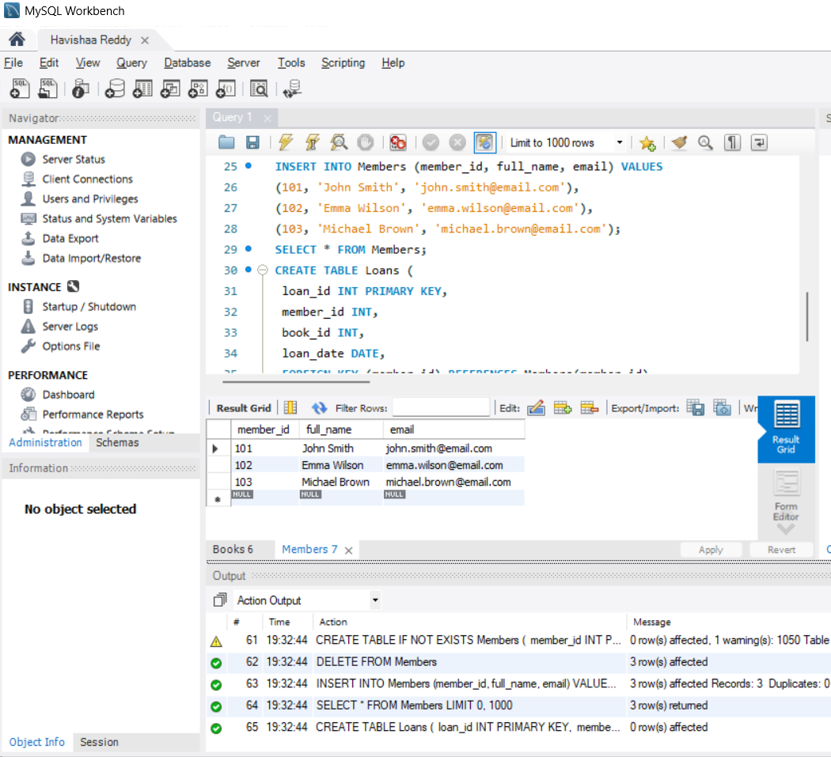

Step 9 & 10 — Insert 10 Loans and Display:

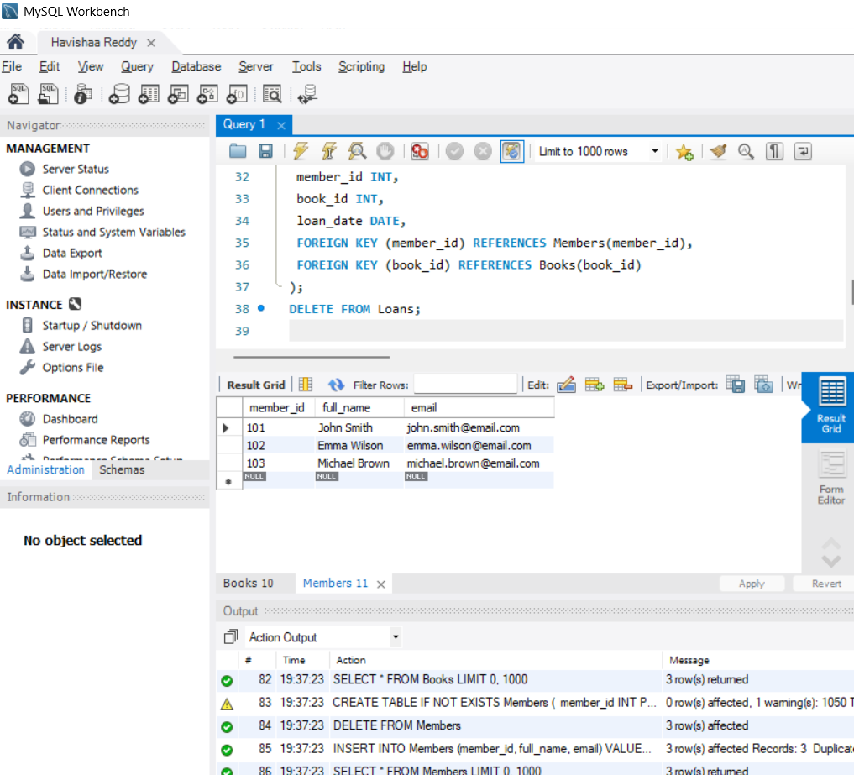

Step 11 — JOIN Query (Who Borrowed What):

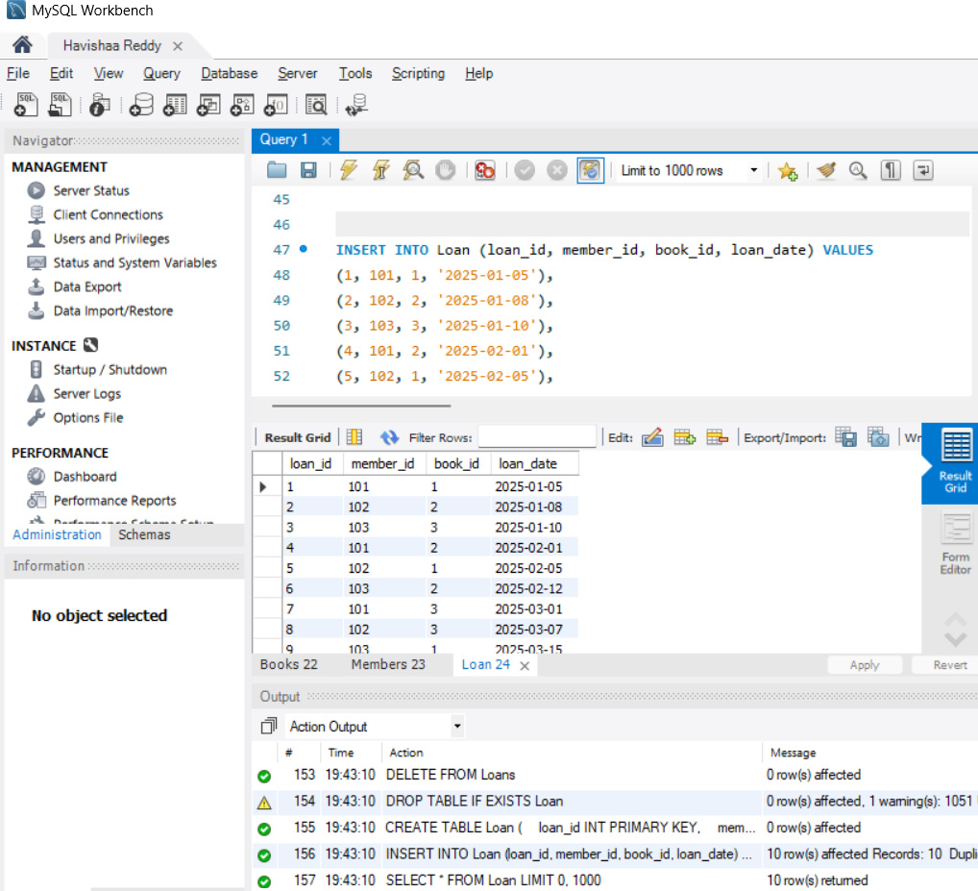

Step 12 — GROUP BY Query (Books per Year):

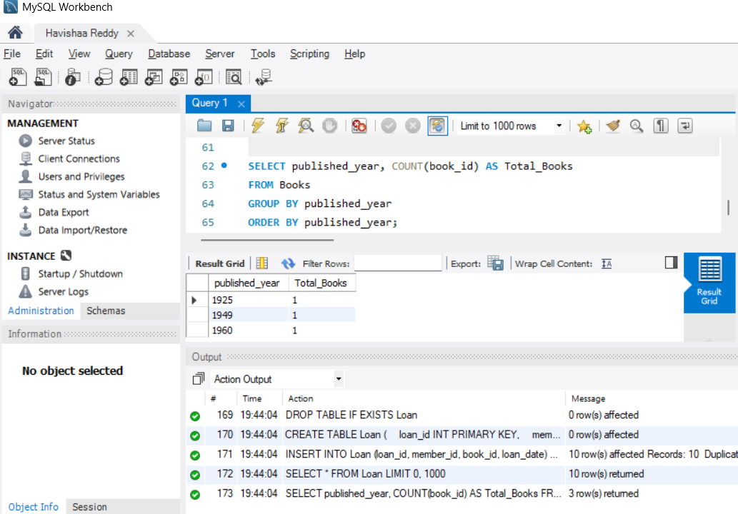

Step 13–16 — Donation via TRANSACTION (Atomicity):

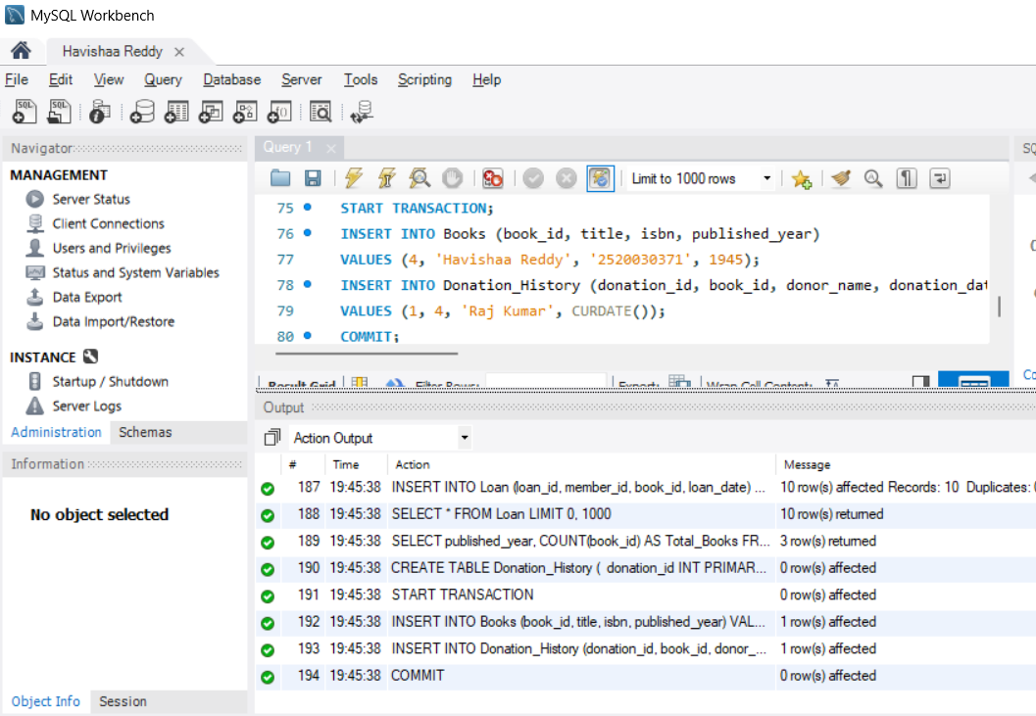

Step 17 & 18 — Index on ISBN + Fast Search:

